**ISE 533 Project 4 Report**

**COVID-19 Problem**

**Shaoqian Chen**

**Tianxiao Yu**

**Qinhao Chang**

**Wei Li**

**Abstract**

This project focuses on establishing a simplified description of a complex process of COVID-19. Since the dynamics of infectious diseases are complex, a transmission dynamic model is needed to improve our fundamental understanding of how a system works and to or project how the system will change over time under the influence of COVID-19. In this project, the group first set up a SEIR+D model to simulate the progress Covid-19 would probably take among people in California, Nevada, and Oregon, based on some statistics provided by CDC and other authorities. For visualization, a time plot will be generated after modelling to present how the number of people in each state changes over time. The major factor we pay attention to is the contact rate, in other words, how quarantine would affect the spread of COVID-19. Besides, the distribution of medical supplies is another critical element to COVID-19 patients. Based on the data of severe patients and number of ventilators, we apply Jiajun’s model to achieve efficient resource allocation.

**Introduction**

Along with a cluster of pneumonia cases in Wuhan, China, a novel coronavirus was identified in late 2019. A pandemic arose, since it has rapidly spread. The World Health Organization designated the disease term COVID-19 (ie, Coronavirus Disease 2019). The virus that causes COVID-19 is designated severe acute respiratory syndrome coronavirus 2 (SARS-CoV-2), whose direct transmission occurs through individual-to-individual contact: through a sneeze or cough, through skin-skin contact, or through exchange of body ﬂuids. We plan to introduce and analyze the most basic transmission model for this directly transmitted infectious disease. Considering COVID-19 has a latent phase during which the individual is infected but not yet infectious, we incorporate the delay between the acquisition of infection and the infectious state within the SIR model by adding an exposed population. Let infected people move from S to E and from E to I. Besides, since the mortality rate is notable, we include an additional state, dead. Starting with a single person, then the whole population.

The major morbidity and mortality from COVID-19 is largely due to acute viral pneumonitis that evolves to acute respiratory distress syndrome (ARDS). Thus, ventilators play a significant role in helping severe patients recover. In this project we will also find the best way to allocate ventilators between three major states in order to fulfill all unmet demand of ventilators in each state and to lower the cost.

**Overview of Models and Methods**

To mimic the progress Covid-19 takes on the society, we build an agent based model of spread of contagious disease. The terminology and overall structure of that problem is taken from the compartmental models in epidemiology, namely from the SEIR (Susceptible Exposed Infectious Recovered) model. The SEIR models the flows of people between four states: susceptible (S), exposed (E), infected (I), and resistant (R). Each of those variables represents the number of people in those groups.

For the sample model, we are considering a population of 10000 people who live in the area 500 by 500 meters and are evenly spread over the area. A neighbor has a connection with everybody who lives closer than 50 meters to him or her. Initially, there is 1 random person who is sick and infectious, while everyone else is susceptible with no immunity. Once a susceptible person contacts any infectious person, the former is likely to get infected with the probability of 0.3, named as Infectivity in the model. Having been infected, people do not immediately become infectious. There is a latent period that lasts around 15 days. Those people in the latent period are called exposed. The duration of the infectious phase, known as illness duration, has an average of 25 days. During the infectious phase, a person comes into contact with an average of 1.25 people each day. When people recover, they get immune to the disease, but not forever. The immunity is assumed to last 2 years, similarly to other coronavirus-related diseases (severe acute respiratory syndrome [SARS] and Middle East respiratory syndrome [MERS]). The parameters are built to control how fast people move from being susceptible to exposed (Exposed Rate ), from exposed to infected (Infectious Rate ), and from infected to recovered (Recovered Rate ), from infected to dead (Fatality Rate ). This model has an additional parameter for those from being recovered to susceptible (Immunity Rate ), since those recovered may get Covid-19 get infected a second time. The output of the model is the number of people in each state over time.

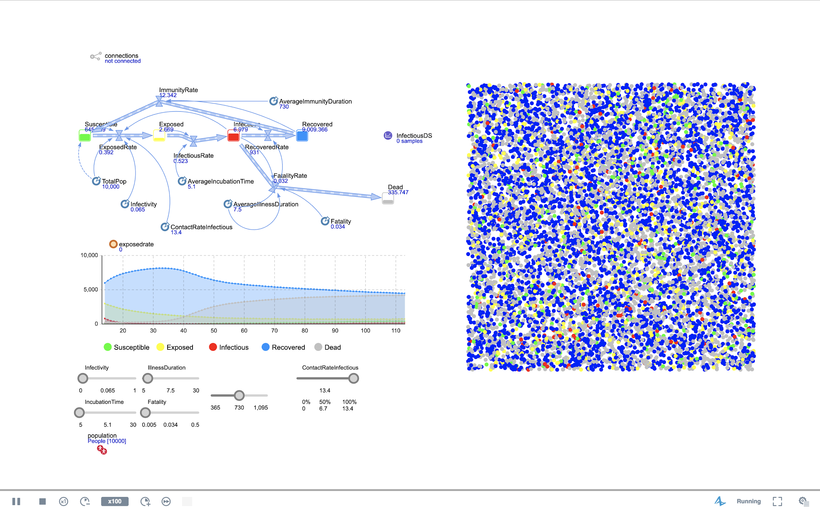

Figure 4.1

Furthermore, a simulation is built based on various values in contact rate. The output plot, figure 4.2, shows that the number of infectious people and the contact rate have a negative correlation.

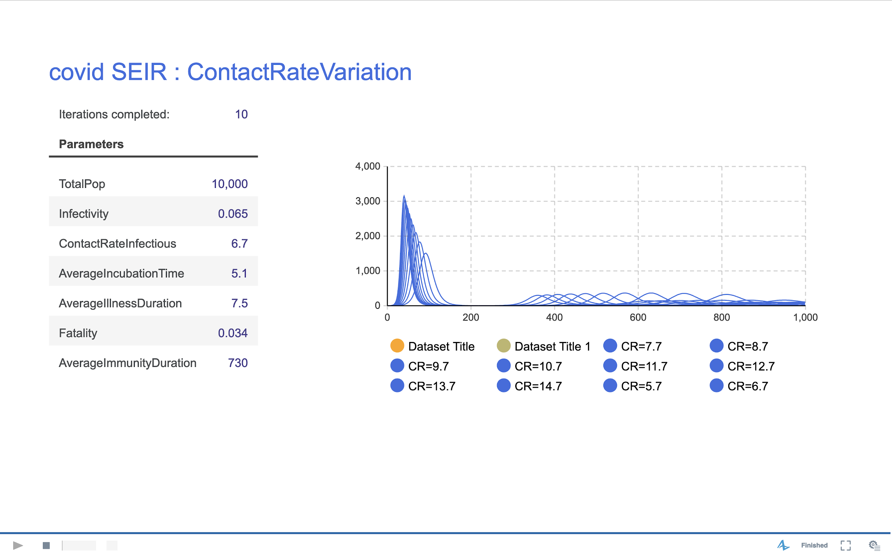

Figure 4.2

Via moving the contract rate slider, we are able to simulate the progress of COVID-19 under various levels of mobility. Figure 4.2 shows how the number of infectious people changes in CA, WA, and NY according to 100% mobility (no restriction on mobility), 80% mobility (slight limits), and 50% mobility (a stay-at-home-order). More decrease in mobility, less infectious people. The process of disease also slows down. A sharp drop happens when mobility shifts from 80% to 50%.

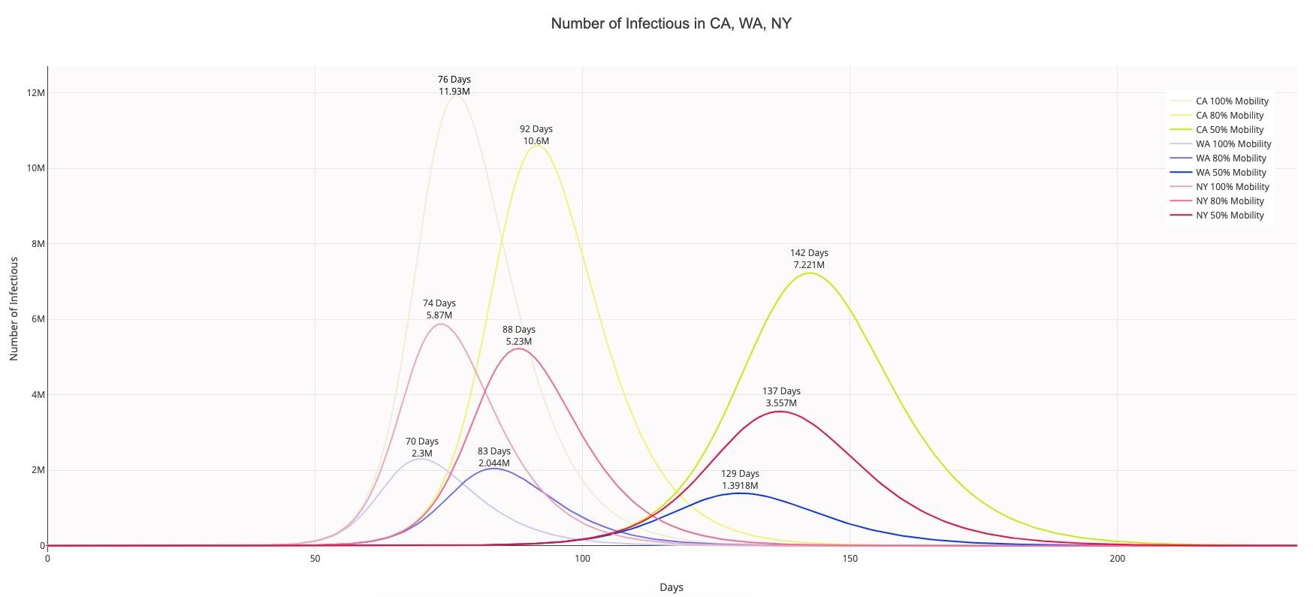

Figure 4.3

|  |  |  |  |
| --- | --- | --- | --- |
| Percent Drop in Peak of Infectious People | Mobility 100% → 80% | Mobility 80% → 50% | Mobility 100% → 50% |
| CA | 11.15% | 31.88% | 39.47% |
| WA | 10.9% | 31.99% | 39.4% |
| NY | 11.13% | 31.91% | 39.49% |

## Table 4.1

Furthermore, we also use our model to explore the situation under different “Stay-at-home” order start date(Fig. 4.4). We pick February 20th, March 19th, and June 20th as three different lock down strategies. And we assume that lock down means dropping the contact rate to 6.7 which is half of the normal value. First of all, if the government of California chooses to lock down the state at the beginning of the epidemic which is February 20th. The trend of exposed, infectious and dead numbers is similar to lock down on March 19th but the peak appears to be almost a month later than the current strategy. On the other hand, if the government of California chooses not to lock down in the early stage, which is represented by the graph of lock down on 6/20/2020. This strategy will bring the largest number of exposed, infectious and dead people. As a result, the decision to lock down on March 19th seems to be a better choice because it not only makes less people involved in this epidemic but also let the whole society return to normal earlier.

Figure 4.4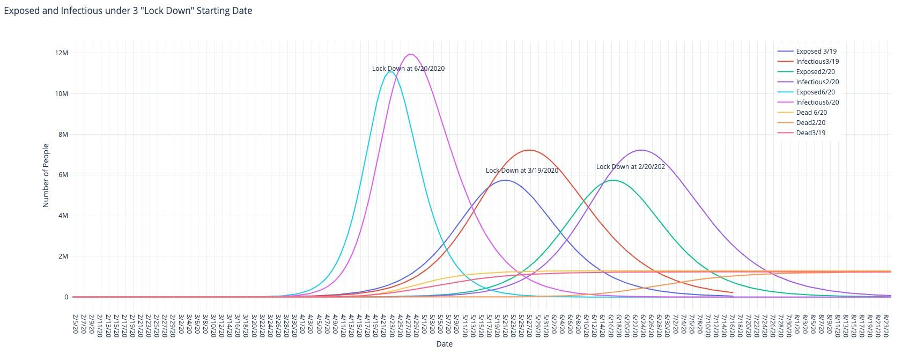

**Ventilator Allocation**

Recent researches have shown that for patients with the worst effects of infection, a ventilator can offer the best chance of survival. According to the World Health Organization (WHO), one person in six becomes seriously ill and in these severe cases, the virus causes damage to the lungs, causing the body’s oxygen levels to drop and making it harder to breathe. To alleviate this, a ventilator is used to push air, with increased levels of oxygen into the lungs.

In this project, we would like to study how to allocate ventilators between California, Washington and New York in order to minimize the unmet demand in each state.

First we assume 14% of the infectious people are in severe condition. This group of people are those who need ventilators. After splitting into three scenarios which are 100%, 80% and 50% mobility in each state, we extract 15 days prediction data of severe ill after May 1st 2020 in each scenario. The model provided by our teaching assistant(Jiajun Xu) is shown below:

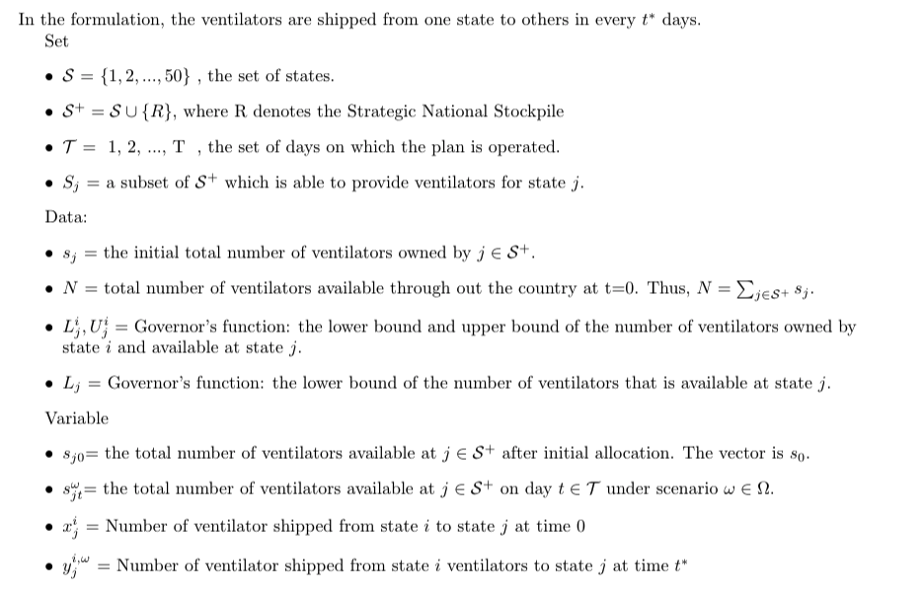

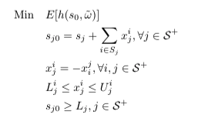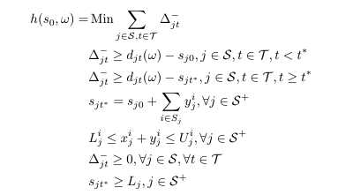

**Results**

Before reallocating the ventilators, the objective value of our model is 9791.33. After allocating ventilators, the total cost is used to 5446.87.

According to the result, in order to accomplish the minimized cost of ventilator allocation, Strategic National Stockpile(SNS) would have to send 1200 ventilators to California(CA), Washington(WA) and New York(NY), CA would have to send 120 ventilators to WA, and send 220 ventilators to WA. WA would have to send 220 ventilators to NY. This result is also shown in the heatmap below (Figure 4.4).

|  |  |  |  |
| --- | --- | --- | --- |
| State/Index | Initial Ventilators | Model Solution | Shipping Flow |
| CA[1,2] | 11036 | 12576 | [-120,-220] |
| WA[0,2] | 1200 | 2500 | [120,-220] |
| NY[0,1] | 2200 | 2960 | [220,220] |
| Strategic National Stockpile(SNS) | 12000 | 8400 | [1200,1200,1200] |
| Cost without Ventilator Allocation | 9791.93 |  |  |
| Cost with Ventilator Allocation | 5446.87 |  |  |

Table 4.2

Figure 4.5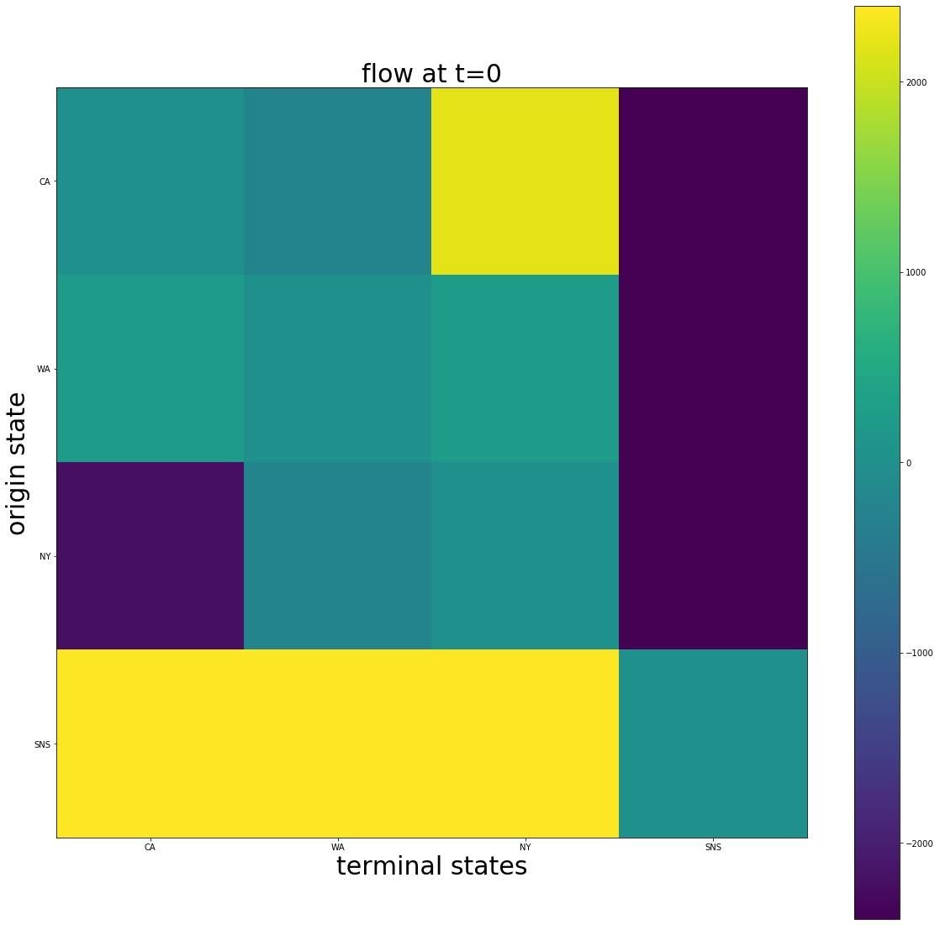

## Lesson Learned, and Recommendation for Future Work

In Summary, our COVID-19 epidemic simulation with the SEIR-D model is functional and simulates the current epidemic with trustworthy results. However there is still a lot of room for improvement. For instance, we have not considered how the use of a medical mask could affect the exposed rate and how the supply of ICU beds affect the recovery rate. Throughout the process of building this simulation system, we have discovered the importance of data analysis in a real world circumstance such as the coronavirus epidemic.

Overall, we have learned a lot from doing this project. And it also raised our understanding of how data analysis helps to analyse a real world situation and to provide suggestions. At the end we would like to express our gratitude to our professor Sen and our TA Jiajun for their kind instruction and help without which we would not get this far.

**References**

Mossong, J., Hens, N., Jit, M., Beutels, P., Auranen, K., Mikolajczyk, R., Massari, M., Salmaso, S., Tomba, G., Wallinga, J., Heijne, J., Sadkowska-Todys, M., Rosinska, M. and Edmunds, W., 2020. Social Contacts And Mixing Patterns Relevant To The Spread Of Infectious Diseases. [online] PLOS MEDICINE. Available at: <https://journals.plos.org/plosmedicine/article?id=10.1371/journal.pmed.0050074#s1> [Accessed 10 May 2020].

Kucharski, A., Russell, T., Diamond, C., Liu, Y., Edmunds, J., Funk, S., Eggo, R., Sun, F., Jit, M., Munday, J., Davies, N., Gimma, A., van Zandvoort, K., Gibbs, H., Hellewell, J., Jarvis, C., Clifford, S., Quilty, B., Bosse, N., Abbott, S., Klepac, P. and Flasche, S., 2020. Early dynamics of transmission and control of COVID-19: a mathematical modelling study. The Lancet Infectious Diseases, 20(5), pp.553-558.

GitHub. 2020. Hopkinsidd/Ncov_Incubation. [online] Available at: <https://github.com/HopkinsIDD/ncov_incubation> [Accessed 10 May 2020].

Sasaki, K., 2020. COVID-19 Dynamics With SIR Model. [online] The First Cry of Atom. Available at: <https://www.lewuathe.com/covid-19-dynamics-with-sir-model.html> [Accessed 10 May 2020].

En.wikipedia.org. 2020. California. [online] Available at: <https://en.wikipedia.org/wiki/California> [Accessed 10 May 2020].

Medicalxpress.com. 2020. Immunity Of Recovered COVID-19 Patients Could Cut Risk Of Expanding Economic Activity. [online] Available at: <https://medicalxpress.com/news/2020-05-immunity-recovered-covid-patients-economic.html> [Accessed 10 May 2020].

JM, W., 2020. Characteristics Of And Important Lessons From The Coronavirus Disease 2019 (COVID-19) Outbreak In China: Summary Of A Report Of 72 314 Cases From T... - Pubmed - NCBI. [online] Ncbi.nlm.nih.gov. Available at: <https://www.ncbi.nlm.nih.gov/pubmed?term=32091533> [Accessed 11 May 2020].